SALES DATASET ANALYSIS
Superstore Sales Analysis and Scenario Summaries
Prepared by: ARDRA PRAKASH
Course: Data Analytics and Data Science
BATCH: August – 2025
Date: October 10, 2025

ABSTRACT

This project focuses on analysing a sales dataset using advanced Excel features to uncover valuable business insights. By applying data cleaning, formulas, and visualization techniques, the study aims to understand sales performance, identify patterns, and support better decision-making. The project integrates advanced Excel tools such as What-If Analysis, Goal Seek, Macros, Power Query, and Power Pivot to enhance the efficiency and accuracy of analysis.

CONTENTS
S.NO | TABLE | PAGE NO
1 | INTRODUCTION | 1
 | 1.1 OBJECTIVE | 2
 | 1.2 KEY GOALS | 2
2 | SYSTEM DESIGN AND IMPLEMENTATION | 3
 | 2.1 DATA DESCRIPTION | 4
 | 2.1.1 DATASET OVERVIEW | 4
 | 2.1.1 DATA CLEANING PROCESS | 4
 | 2.2 DATA CLEANING | 5
3 | DATA ANALYSIS | 6
 | 3.1 KEY METRICS AND CALCULATIONS | 6
 | 3.2 KEY METRICS | 6
 | 3.3 DASHBOARD OVERVIEW | 7
 | 3.4 PIVOT TABLE AND PIVOT CHARTS | 7
 | 3.4.1 PIVOT TABLE | 7
 | 3.4.2 PIVOT CHARTS | 8
 | 3.4.3 VISUVALIZATION | 8
 | 3.4.4 KEY PERFORMANCCE INDICATORS | 8
 | 3.4.5 SLICER | 9
4 | ADVANCED ANALYSIS | 10
 | 4.1 WHAT-IF ANALYSIS | 10
 | 4.2 SECNARIO MANAGER | 11
 | 4.3 GOAL SEEK | 12
 | 4.4 MACROS | 13
 | 4.5 MACROS BUTTON | 13
5 | INSIGHTS AND RECOMMENDATIOS | 15
 | 5.1 INSIGHTS | 15
 | 5.2 RECOMMENDATIONS | 15
6 | CONCLUTION | 17

- INTRODUCTION

Data analysis plays a vital role in understanding and improving business performance. In this project, the sales dataset from a retail business is analysed using Microsoft Excel to extract meaningful insights. The dataset contains transaction-level information, including order dates, sales amounts, discounts, and product details. The goal is to transform raw data into an organized, visual, and interactive report that highlights key performance indicators (KPIs) and trends.

1.1 OBJECTIVE

The primary objective of this project is to perform a comprehensive analysis of sales data using advanced Excel tools. Specific goals include analyzing sales trends, identifying high-performing products and customer segments, assessing the impact of discounts on revenue, and creating an interactive sales dashboard that summarizes overall performance.
1.2 KEY GOALS:
- Examine sales patterns across different time periods to identify trends and seasonal variations.
- Highlight top-selling products and determine the most effective sales platforms contributing to higher revenue.
- Assess the impact of returns and discount strategies on total revenue and profitability.
- Identify areas for sales improvement based on data-driven insights.
- Support better business decisions by understanding performance across products, time periods, and channels.

- SYSTEM DESIGN AND IMPLEMENTATION
The project began with the preparation and formatting of the dataset. Columns were formatted for readability, and date fields were standardized to ensure accurate filtering and sorting. Duplicate and blank entries were removed, and data validation rules were applied to prevent errors such as negative sales or discounts. The IF and IFERROR functions were used to identify and correct invalid entries.
Next, sales performance analysis was conducted by calculating total and adjusted sales after discounts. Using Excel formulas like COUNTIFS, AVERAGEIF, and SUMIFS, the dataset was segmented by product category, region, and customer segment to identify performance variations. Time-based analysis was carried out using PivotTables and Excel’s date functions (MONTH, YEAR, WEEKDAY) to detect seasonal trends and peak periods.
The What-If Analysis and Goal Seek tools were used to test business scenarios, such as determining the sales required to achieve a specific profit goal or the impact of discount rate changes. This helped in understanding how key variables influence revenue and profitability.

2.1 DATA DESCRIPTION:
2.1.1 DATASET OVERVIEW:
9900+ rows, columns such as Order ID, Sale ID, Product Type, etc.
2.1.2 Data cleaning process:
The dataset was thoroughly cleaned and formatted to ensure accuracy and consistency. Dates were standardized to dd-mm-yyyy, while duplicate and blank records were removed to maintain data integrity. Numeric fields, such as sales and quantity, were rounded to two decimal places, discounts were formatted as percentages (%), and profits were displayed as currency ($) for clarity. Conditional formatting was applied to highlight important patterns, such as high profits or significant discounts, making trends easier to identify. These steps prepared the dataset for reliable analysis, enabling accurate reporting, PivotTables, charts, and further Excel-based insights.

2.2 DATA CLEANING:
2.2.1 RAW DATA
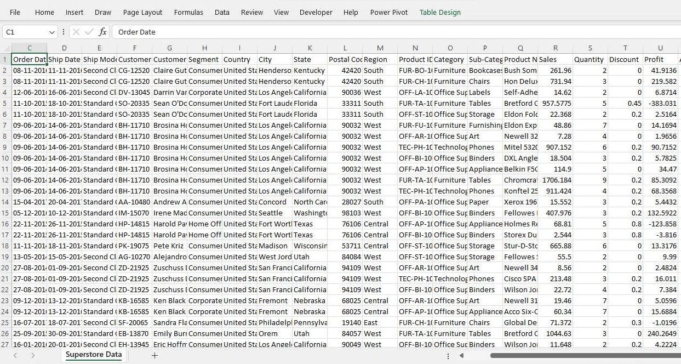

2.2.2 CLEANED DATA

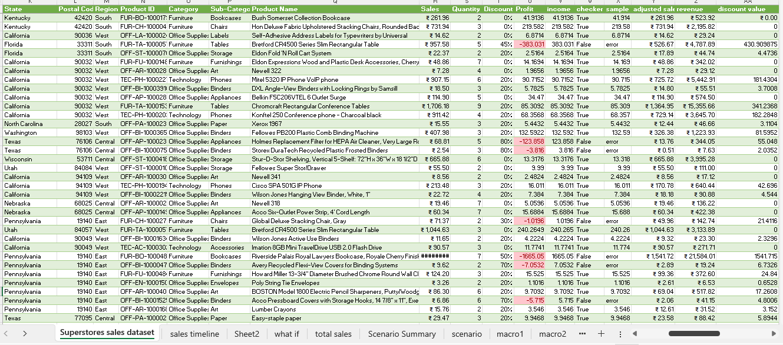

- DATA ANALYSIS
3.1 KEY METRICS and CALCULATIONS
The total sales were calculated using the formulas =SUM (Sales_Amount) for Gross Sales and =Net_Sales - SUM (Dscount_Amount) for Adjusted Sales. This helped identify the overall revenue after applying discounts. The average sales per order were determined using =AVERAGE (Sales_Amount) to find the general sales value per transaction.
In some cases, =AVERAGEIF (Order_Type, "Furniture", Sales_Amount) was used to compare specific product categories. The total discounts were analysed using =SUM (Discount_Amount)/SUM(Gross_Sales), showing the percentage of revenue reduced due to discounts.
Pivot Tables and Pivot Charts were created to visualize and compare sales across different categories. From the analysis, Technology and Office Supplies emerged as top-performing categories, while Standard Class was the most preferred shipping mode.
This approach provided a clear understanding of how discounts, order types, and categories influence total revenue, enabling more accurate decisions for improving overall sales performance.

3.2 KEY METRICS :
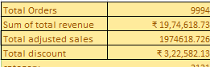
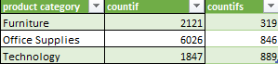
3.3 DASHBOARD OVERVIEW
An interactive dashboard was created to summarize the results of the analysis. The dashboard included key metrics such as total sales, average order value, total discounts, and top-performing product categories. PivotTables and Pivot Charts were used to visualize trends and performance across dimensions. Slicers and data validation features were added to allow users to filter results by date, product category, or shipping mode dynamically.
3.4 PIVOT TABLES AND PIVOT CHARTS:
3.4.1 Pivot Table:
Pivot Tables were used to quickly summarize and analyse large volumes of sales data across multiple dimensions. I created separate PivotTables to group and aggregate sales by sales channel (Ship Mode), product category, and order date. For example, by placing Ship Mode in the rows and Adjusted Sales in the values area, I could easily compare total revenue across different shipping methods.
Another PivotTable grouped sales by Product Category and Sub-Category to identify the best-selling product types. I also used Order Date to create a time-based PivotTable, showing monthly and quarterly sales trends.
These PivotTables helped visualize patterns such as peak sales periods, top-performing products, and discount effects. Combined with Pivot Charts, they made the analysis more interactive and insightful, allowing quick filtering and comparisons through slicers for Category, Segment, and Ship Mode.

3.4.2 PIVORT CHART
A Pivot Chart is a dynamic chart linked directly to a PivotTable that visually represents summarized data. It automatically updates when the PivotTable changes, making data analysis faster and easier. Pivot Charts allow interactive filtering using slicers to explore different segments of the data. They support various chart types like column, bar, line, and pie for flexible visualization. Pivot Charts help quickly identify trends, patterns, and comparisons across multiple dimensions.
3.4.3 VISUALIZATION
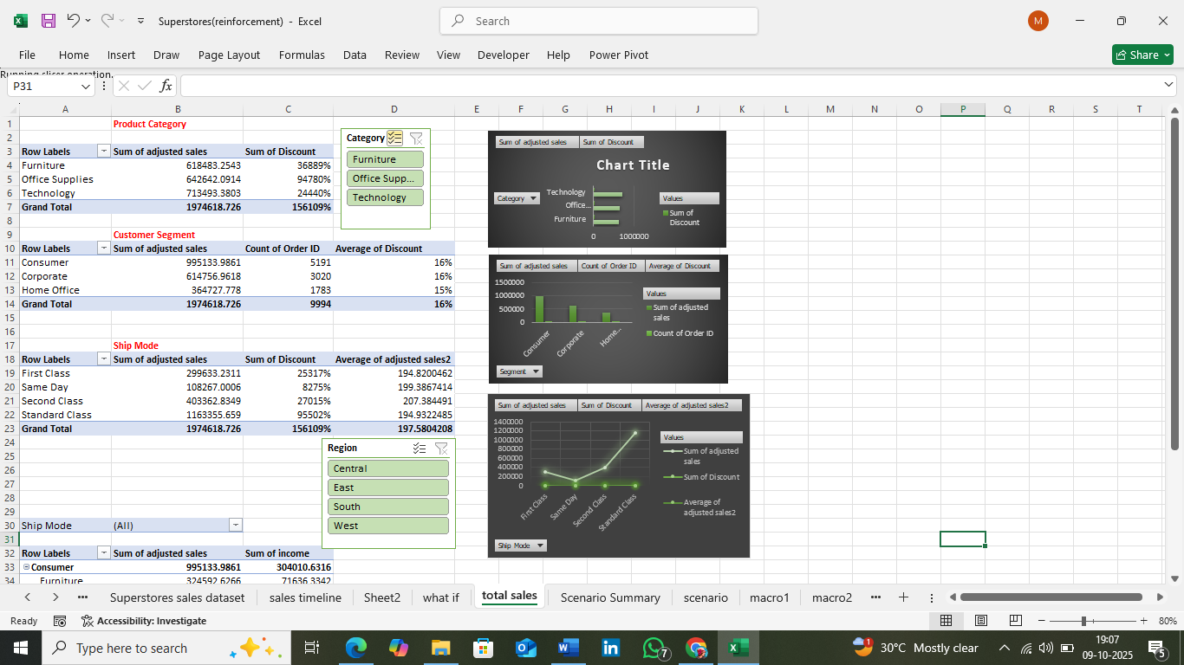

3.4.4 KEY PERFORMANCE INDICATORS
The dashboard tracks essential KPIs such as Total Sales, Average Sales per Order, Total Discounts, and Profit Margin. It also highlights Top-Performing Product Categories, Sales by Region, and Sales Trends over Time. These KPIs provide a clear overview of business performance, helping identify profitable areas, monitor discount impacts, and support informed, data-driven decisions to improve overall sales effectiveness and growth.
3.4.5 Slicer
Slicers act as interactive filters that allow users to easily explore and analyse data across different dimensions such as Customer Segment, Product Category, and Ship Mode. By simply clicking on a slicer option, users can instantly filter PivotTables and charts to view specific subsets of data. This enhances interactivity, improves data visualization, and helps users quickly identify patterns, trends, and insights within selected segments of the sales data.
3.4.6 DASHBOARD VISUALIZATION

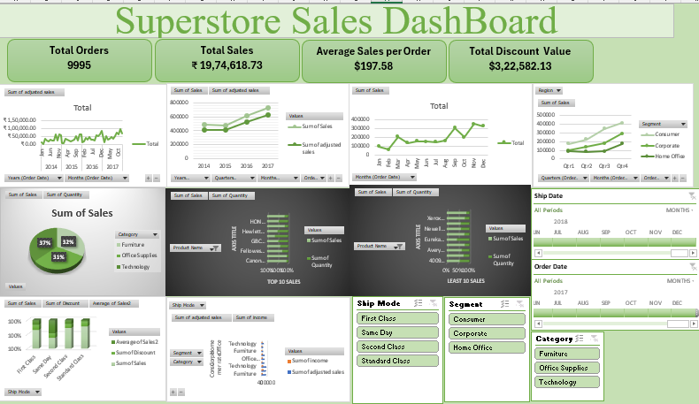

- ADVANCED ANALYSIS
4.1 WHAT-IF ANALYSIS:
A What-If Analysis was performed to examine how varying discount rates impact total revenue and profit. By adjusting discount percentages, different sales scenarios were simulated to identify the optimal balance between offering discounts and maintaining profitability. This analysis helped in making strategic pricing and promotional decisions.
The analysis showed that a 5% discount slightly increased sales, encouraging more purchases while having minimal impact on overall profit. A 10% discount, however, led to a more substantial rise in sales by attracting more customers and higher order volumes. Despite the increased revenue from higher sales, this larger discount noticeably reduced profit margins due to lower earnings per unit.
These results highlight the importance of balancing sales growth with profitability, indicating that moderate discounts can stimulate purchases without significantly harming overall financial performance, while larger discounts may compromise profit despite boosting sales.
- Net Value Calculation:=Sales*(1-Discount)*Quantity
- 5% Decreased Discount:=Netvalue*((1-Discount)-0.05)
- 10% Increase in sales:=Netvalue*1.1
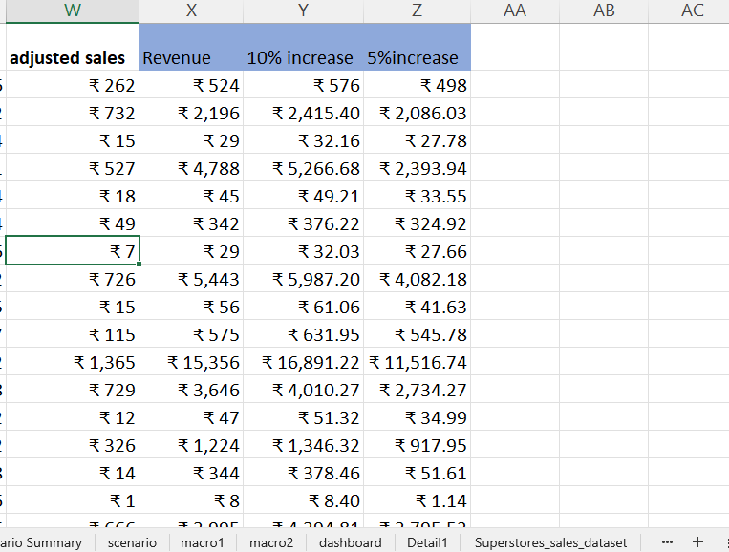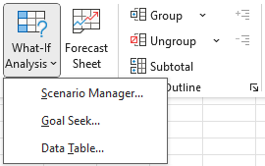
4.2 SECNARIO MANAGER:
- The Scenario Summary Tool in Excel was used to compare results from multiple What-If scenarios.
- Two discount scenarios — 5% and 10% — were created using Scenario Manager to simulate different pricing strategies.
- Each scenario adjusted the discount rate to see how it would affect sales and profitability.
- A summary report was generated to show key metrics such as Total Sales, Net Revenue, and Profit for each scenario.
- The side-by-side comparison made it easy to observe the impact of small changes in discount rates on overall business performance.
- This allowed stakeholders to analyse and understand the relationship between discount levels, sales volume, and profit margins.
- By reviewing the results, decision-makers could determine which discount strategy maximized sales while maintaining profitability.
- Overall, the tool provided actionable insights for pricing decisions and strategic planning in a clear and organized format.

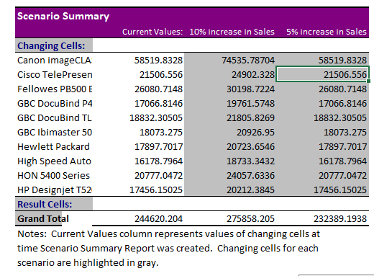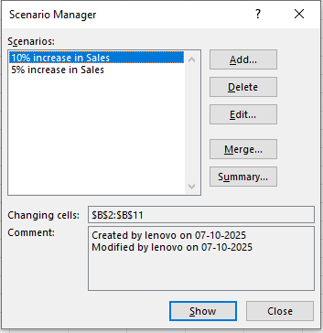
4.3 GOAL SEEK:
Goal Seek in Excel was used to determine the exact number of units needed to achieve a target outcome, considering the selling price per unit and the average discount rate.
This method allowed for precise calculations, helping to identify sales requirements and make informed pricing and inventory decisions efficiently.
- You have a formula with an unknown input.
- You set the target value you want the formula to reach.
- Goal Seek adjusts the input automatically to achieve that target.
How it Works:
Data → What-If Analysis → Goal Seek.
- Set cell: Net Value cell
- To value: 5000
- By changing cell: Quantity

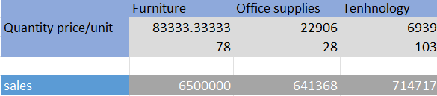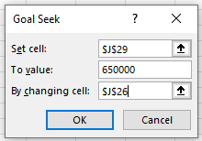

4.4 MACROS:
Macros were created in Excel using the Record Macro feature to automate repetitive tasks and streamline workflow. These macros captured a series of actions, including applying consistent formatting such as currency symbols, borders, and bold headers, ensuring uniformity across the dataset. They also automated data calculations for key metrics like sales, discounts, and net values, reducing manual effort and minimizing errors.
Additionally, the macros facilitated the automatic creation or refreshing of PivotTables and charts, allowing updated reports to be generated quickly and efficiently, improving productivity and reporting accuracy.

4.5 Macros Button
A Macros Button in Excel is a clickable button that runs a macro to automate tasks. It executes a sequence of recorded or written commands with a single click.
Macros Buttons save time by performing repetitive actions automatically.
They can be customized and assigned to any macro on a worksheet or ribbon.
This allows users to run complex processes without manually performing each step.
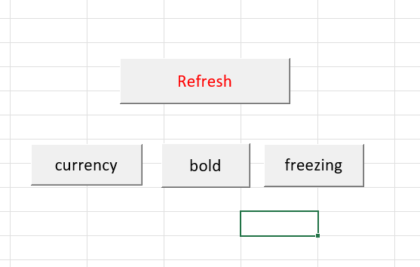

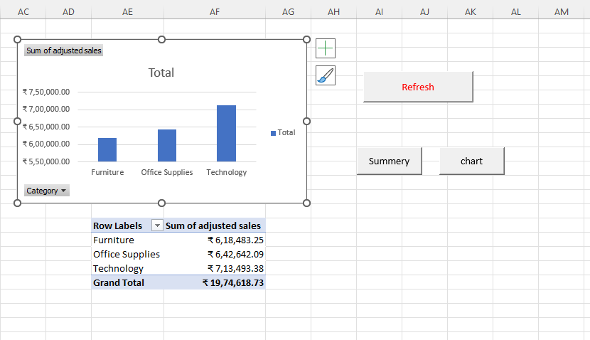

- INSIGHTS AND RECOMMENDATIONS:
5.1 INSIGHTS:
The analysis highlighted the best-performing sales channels and products. Among shipping methods, Standard Class generated the highest sales. In terms of products, Technology items earned the most revenue, while Office Supplies were sold in large quantities. Although Furniture recorded fewer sales, it showed higher order values, indicating strong per-order profitability.
Discount trends revealed that the average discount across orders was approximately 15%. While higher discounts boosted sales volume, they tended to reduce overall profit. Moderate discounts in the range of 10–20% proved most effective, balancing increased sales with healthy margins. Corporate customers typically received lower discounts, yet maintained steady sales, reflecting their consistent purchasing patterns.
Seasonal patterns showed peak sales during November and December, coinciding with the year-end festive season, while sales were lowest between February and April. Understanding these trends helps in planning pricing strategies, inventory, and promotions to maximize revenue and profitability throughout the year.
5.2 RECOMMENDATIONS
- Focus on Standard Class shipping and high-revenue products like Technology items.
- Offer moderate discounts (10–20%) to boost sales while maintaining profit margins.
- Increase marketing efforts and inventory during peak months (November–December).
- Use low-sales months (February–April) for targeted promotions to stimulate demand.
- Monitor high-value orders and seasonal trends to optimize pricing, inventory, and profitability.

- CONCLUSION:
The analysis provided insights into sales performance, product trends, and discount strategies. Online sales were the top-performing channel, and among products, Technology, Office Supplies, and Furniture contributed most to revenue. A 5% discount slightly increased sales while maintaining profits, whereas a 10% discount raised sales but reduced profit. PivotTables, Pivot Charts, What-If Analysis, Goal Seek, and Macros were used to aggregate data, simulate scenarios, and automate repetitive tasks. The interactive dashboard allowed stakeholders to explore data and make informed decisions.

